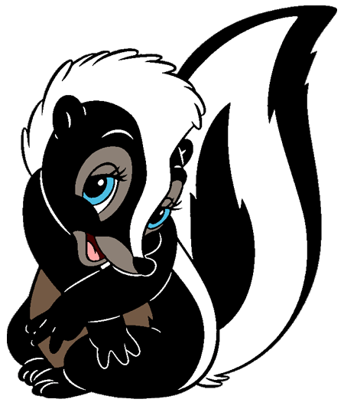
Camp Segonku
“Greek Mythology”
Patch Design Contest 2026

All campers may submit a design for our PATCH / T-SHIRT contest. Runner ups may see their design on the Songbook, Camper Council Booklet, Camper Pick-up Card, Parent Confirmation Letter or even the Leader’s Guide,
Be sure to include the following:

- “Camp Segonku”
- “2026”
- “Greek Mythology”
- Stinky (our skunk mascot)

\
\\

OR

YOU DO NOT NEED TO USE THIS FORM TO SUBMIT A PATCH DESIGN.
PLEASE COLOR YOUR DESIGN. You may use crayons, colored pencils or markers. Submit your design by May 10th, via scan or photo upload to: CampSegonku@gmail.com

The winner will be announced on May 15th and receive a FREE CAMPERSHIP for camp this summer (refund your camp fee if already paid) PLUS your design will be on every t-shirt & patch, the Segonku website and it will go down in Camp Segonku history!

__________________________________________ ________________________
Name Phone

Please visit us at www.campsegonku.org to see last year’s winning patch.

